Viewing, Listening and Speaking, Book 4 Units 1-5 review

Speak for 1-2 minutes about one topic (teacher will choose your topic at the beginning of the exam)

# Unit 1 (Free Therapy)

* Upgrade your life (pg 12 + 13) Should you upgrade your life?

Things to do on the weekend to improve your life?

Eg: exercise, express gratitude, enjoy your hobbies, etc.

* Suggested topics (pg 14)

1. A place you know well
2. A good friend
3. A TV show you enjoy

* Smiling (pg 11 + 19)

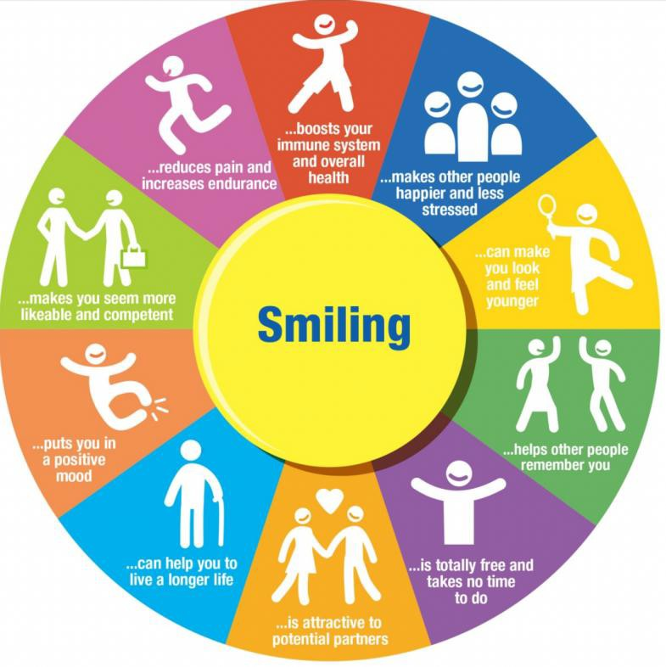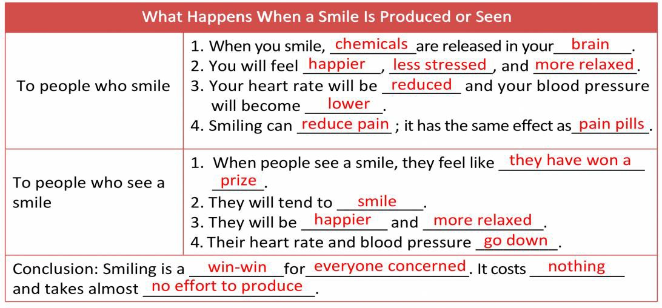

Reasons for smiling?

# Unit 2 (The Right to Know)

* What would you ask? (pg 29)

Which company would you question? What would you ask? Why would you ask this?

* Transparency (pg 37)

Examples of companies being transparent?

Positives and negatives of companies being transparent? Transparency Vs privacy?

Examples of being transparent in other relationships? Eg :doctors being transparent about their training and experience when they speak to their patients.

# Unit 3 (Listen up!)

* The business of listening (pg 50)

What are some jobs for which listening skills is very important?

Other important skills include speaking, writing and reading. Which skill is most valuable?

Why is listening important?

* Listening styles (pg 53) What is your listening style?

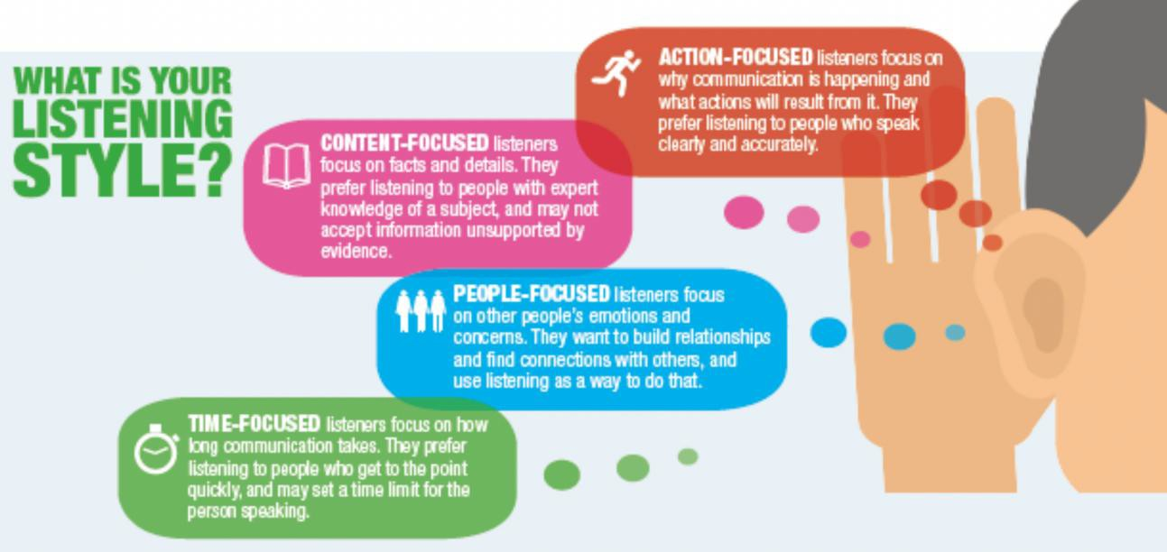Advantages and disadvantages of each style?

* Humour (pg 60) 2 types of humour

Advantages and disadvantages of using humour?

Do you use humour when speaking English? Why or Why not?

# Unit 4 (Big Data)

* What is big data? (pg 71)
* Datatainment (pg 72) What is datatainment? Examples of datatainment?
* Predictable entertainment (pg 75)

What do you think is most predictable, books, movies, music, TV shows or video games?

* Big data in business (pg 83)

How is big data used in different industries?

# Unit 5 (Fear Factor)

* Fear in the media (pg 98)

Have you ever been affected after hearing a news story in the media? Does the media make things sound worse than they are?

* Domains of fear (pg 101) Different categories of fear What are you afraid of? Effects of fear?

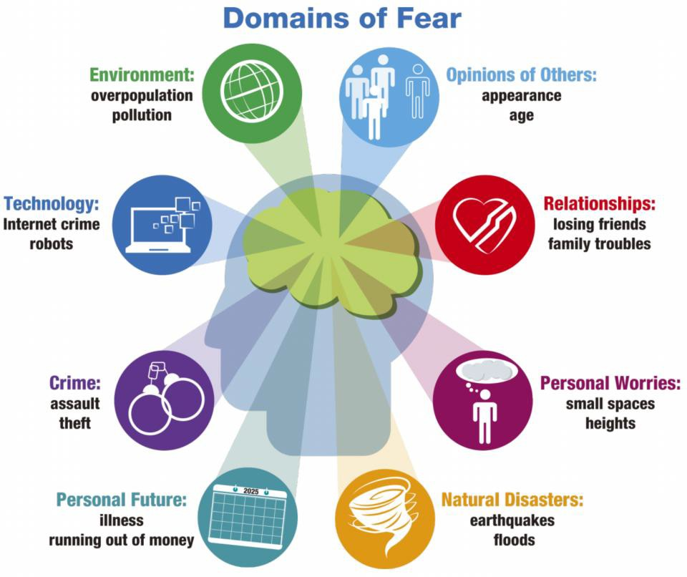

**Grading**

|  |  |  |  |  |  |
| --- | --- | --- | --- | --- | --- |
| 1. Good comprehension of topic | 1 | 2 | 3 | 4 | 5 |
| 2. Clearly explained topic in detail | 1 | 2 | 3 | 4 | 5 |
| 3. Used pauses effectively | 1 | 2 | 3 | 4 | 5 |
| 4. Spoke accurately and fluently | 1 | 2 | 3 | 4 | 5 |
| 5. Clear pronunciation | 1 | 2 | 3 | 4 | 5 |

Low (1)- high (5)